**COSK1003 - Essential Professional and Academic Skills**

**for Masters Students**

**2023-24 Term 2**

**Tasks Report**

**Amara Navya**

**001366861-7**

**M.sc (Data Science)**

**Table of Contents**

1

2

.

.

Introduction ........................................................................................................................1

Task 1 - Effective formal communication (forum, video and email).................................2

.1 Activity A - Profile photo............................................................................................2

.2 Activity B - Forum......................................................................................................2

.3 Activity C - Formal video ...........................................................................................2

.4 Activity D - Formal email...........................................................................................2

Task 2 - Professional and academic writing.......................................................................3

.1 Activity A - Plagiarism ...............................................................................................3

.2 Activity B - Academic writing....................................................................................4

Task 3 - Formal Report.......................................................................................................5

.1 Activity A - Tasks report.............................................................................................5

Tutor’s feedback.................................................................................................................6

Conclusion..........................................................................................................................7

2

2

2

2

3

4

.

.

3

3

4

5

6

.

.

References..................................................................................................................................8

ii

**Table of Figures**

Figure 1. Screenshot of the Avoiding Plagiarism Quiz result ...................................................3

Figure 2. Screenshot of the TurnItIn Quiz result .......................................................................3

Figure 3. Screenshot of tutor’s feedback ...................................................................................5

iii

**1**

**. Introduction**

The aim of the report for the course COSK1003 "Essential Professional and Academic Skills for Master's Students," is to focus on effective formal communication and professional and academic writing. The report is organized into three main sections corresponding to the course's primary tasks. Such as

**Task 1:** Effective Formal Communication, which is further subdivided into three activities Activity A - Profile Photo: Adding photograph to my university’s MS-Office profile and university profile page in Moodle.

Activity B – Forum: Posting my home country forum with information including my town/city and country, Official languages of my town and traditional dishes in my city.

Activity C – Formal Video: Recorded a 40sec formal video using Panopto tool and video about my introduction and my programme.

Activity C – Formal Email: Composed a formal email to tutor about Lecture and Moodle.

**Task 2:** It has 2 activities, Which will about academic writing including referencing and plagiarism.

Activity A - Plagiarism: It is about plagiarism and how to avoid it.

Activity B – Academic Writing: It is about academic style writing and including referencing using Harvard referencing style.

1

**2**

**. Task 1 - Effective formal communication (forum, video and**

**email)**

**2**

**.1 Activity A - Profile photo**

Done

**2**

**.2 Activity B - Forum**

Forum Post : <https://moodlecurrent.gre.ac.uk/mod/forum/discuss.php?d=360182>

Response : <https://moodlecurrent.gre.ac.uk/mod/forum/discuss.php?d=360216&parent=612269>

**2**

**.3 Activity C - Formal video**

Formal Video: <https://gre.cloud.panopto.eu/Panopto/Pages/Viewer.aspx?id=6505f50c-5580-4b7a-947a-b11d01344c58>

**2**

**.4 Activity D - Formal email**

Subject: COSK1003-Task 1 (Activity D)

Dear Dr Asim,

I hope this email finds you well. Yes, I attended the COSK1003 welcome week lecture and looking forward to further engagement throughout the semester.

Yes, I have viewed the COSK1003 welcome week lecture slides. Thank you for providing them. They were helpful in understanding the course material.

Best regards,

A Navya

Student ID : 001366861-7

M.sc Data Science

2



**3**

**. Task 2 - Professional and academic writing**

**3**

**3.1 Activity A – Plagiarism**

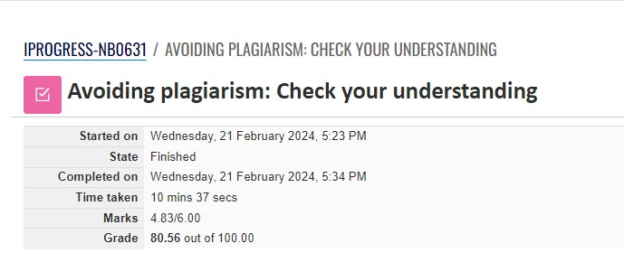

Figure Plagiarism Test

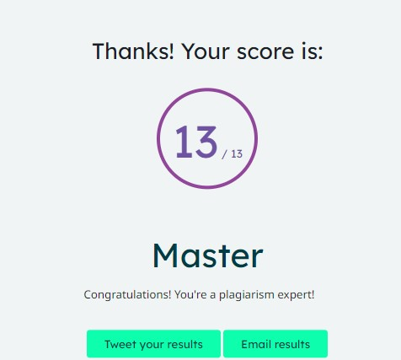

Figure Turnitin Test

3

**.2 Activity B - Academic writing**

In the assessment of AI capabilities compared to human intelligence, it is acknowledged that while AI has made substantial progress, certain fundamental aspects still present challenges. The discussion, as outlined, emphasizes the strengths of human intelligence, such as creativity, intuition, emotional intelligence, and ethical reasoning, which currently surpass the abilities of AI systems (Anonymous, 2024). The human capacity for adaptability, learning transfer across domains, and the innate understanding of real-world contexts are noted as unique attributes. The article underscores that AI, lacking consciousness and personal experiences, faces limitations in comprehending the complexity of human life. Additionally, the ethical considerations surrounding bias in AI and the absence of true creativity and emotional understanding contribute to the argument that AI may not fully outsmart humans in all dimensions. While recognizing the dynamic nature of AI development, the article maintains a cautious perspective, highlighting the enduring disparities between AI and the comprehensive facets of human intelligence.

I agree with the article's emphasis on human strengths in creativity, emotional intelligence, and ethical reasoning, supported by scholarly works emphasizing the unique qualities of human cognition (Damasio, 1994; Sternberg, 2003). However, I find the statement about AI lacking consciousness as a limitation somewhat overstated. Some argue that consciousness is not a prerequisite for intelligence and can be simulated to a certain extent (Hawkins & Blakeslee, 2004; Koch, 2012). The article's cautionary stance aligns with the idea that ethical concerns, including bias in AI, require ongoing attention (Diakopoulos, 2016). Yet, it could benefit from acknowledging the evolving nature of AI ethics frameworks and practices (Floridi et al., 2018). Overall, while the article provides a comprehensive overview, nuances in the evolving field of AI warrant a more balanced perspective.

**3**

**4**

**. Task 3 - Formal Report**

**4**

**.1 Activity A - Tasks report**

This report has been created for Activity A of Task 3.

5



**5**

**. Tutor’s feedback**

6

**6**

**. Conclusion**

The aim of the report for the course COSK1003 "Essential Professional and Academic Skills for Master's Students" is to really hone in on the importance of effective formal communication and professional and academic writing. It's all about equipping the skills i need to communicate my ideas clearly and professionally in various academic and professional settings. This includes mastering the art of writing reports, essays, and other formal documents that showcase their knowledge and expertise. By focusing on these skills, the aim is to empower my master's to excel in my academic and future professional endeavors.

7

**References**

1. Yang, Z., Dai, Z., Yang, Y., Carbonell, J., Salakhutdinov, R.R. and Le, Q.V., 2019. Xlnet: Generalized autoregressive pretraining for language understanding. Advances in neural information processing systems, 32.

McAfee, A. and Brynjolfsson, E., 2017. Machine, platform, crowd: Harnessing our digital future. WW Norton & Company.

Mittelstadt, B.D., Allo, P., Taddeo, M., Wachter, S. and Floridi, L., 2016. The ethics of algorithms: Mapping the debate. Big Data & Society, 3(2), p.2053951716679679.

Dimakos, I.C. and Tasiopoulou, K., 2003. Attitudes towards Migrants: what do Greek students think about their immigrant classmates. Intercultural Education, 14(3), pp.307-316.

Ghillani, D., 2022. Deep learning and artificial intelligence framework to improve the cyber security. Authorea Preprints.

8